 

WordPress

ZAR League of hotels – Project report

AREHMAN JAMAL  
IYER RAHUL RAJAN

ZUBIN KADVA

*Under the guidance of*

Mrs. Soorya Pillai

2014

**ACKNOWLEDGEMENT**

Our team has taken immense efforts in this project. However, it would not have been possible without the kind support and help of many individuals and organizations. I would like to extend my sincere thanks to all of them.

I am highly indebted to Mrs. Soorya Pillai for her guidance and constant supervision as well as for providing necessary information regarding the project & also for her support in completing the project.

I would like to express my gratitude towards my parents & members of Navinchandra Mehta Institute of Technology and Development for their kind co-operation and encouragement which helped us in the completion of this project.

My thanks and appreciations also go to my colleagues and people who have willingly helped me out with their abilities.

|  |  |  |  |  |  |  |
| --- | --- | --- | --- | --- | --- | --- |
| Deccan Education Society’s  NAVINCHANDRA MEHTA INSTITUTE OF TECHNOLOGY AND DEVELOPMENT  WORDPRESS – ZAR LEAGUE OF HOTELS  SUBMITTED BY   |  |  |  | | --- | --- | --- | | Iyer Rahul Rajan | Arehman Jamal | Zubin Kadva | | 5321 | 5324 | 5327 |   **2014 - 15**    Submitted to University of Mumbai  in partial fulfillment of the requirements for qualifying  MASTER OF COMPUTER APPLICATION   Examination |

**Deccan Education Society’s**

NAVINCHANDRA MEHTA INSTITUTE OF TECHNOLOGY AND DEVELOPMENT

|  |
| --- |
| **PROJECT CERTIFICATE**  This is to certify that the Project done at Navinchandra Mehta Institute Of Technology And  Development_ by Mr. Iyer Rahul Rajan , Mr. Arehman Jamal and Mr. Zubin Kadva  (Roll No. 5321, 5324 and 5327) in partial fulfillment for MCA Second Year End Project has been found satisfactory. This report has not been submitted for any other examination and does not form part of any other course undergone by the candidate.  Internal Guide Professor In-charge  College Stamp  EXAMINED BY  EXTERNAL EXAMINER ………………………………  DATE: |

Table of Contents

Introduction 1

Who can use WordPress? 2

Benefits of using WordPress 3

Login 4

The Dashboard 4

Dashboard menu options 5

Permalinks 6

Pages and Posts 7

Posts 7

Pages 8

Child Pages 8

Appearance 9

Widgets 10

Plugins 11

What Is a Plugin? 11

Comparing WordPress, Joomla and Drupal 12

Case Study – Hotel Management 15

Pages 15

Theme 16

Plugins 17

Screens 18

References and Bibliography 23

# Introduction

WordPress is an open source blog software package that works exceptionally well as a content management system, a blog system, or a traditional website. It makes it easy for anyone to set up, manage and maintain a website—without having an advanced degree in geekery. WordPress started in 2003 and is now the largest self-hosted blogging tool and is used on, literally, millions of sites worldwide.

WordPress is an Open Source software system used by millions of people around the world to create beautiful websites and blogs. It is completely customizable by the use of themes and plugins.

*“WordPress is web software you can use to create a beautiful website or blog. We like to say that WordPress is both free and priceless at the same time.”*

Themes can be easily downloaded from the official WordPress site or from hundreds of other places around the web. The same goes with plugins, which are used to extend the functionality of your WordPress site.

As well as being a fantastic blogging and content management system, one of the huge benefits is the wealth of information out there. There’s a great community of people behind the design & development of the WordPress system itself. People from all over the world contribute their time, knowledge and skill to keeping WordPress updated and secure.

There’s also a huge number of designers, developers & bloggers who share their knowledge through blog posts, tutorials, reviews, videos and the creation of thousands of themes & plugins.

WordPress powers a staggering amount of websites. In fact, it powers 23% of the whole web! Everything from personal blogs to large corporate websites.

# Who can use WordPress?

The short answer is anyone. WordPress is a pretty powerful system and it can easily be customized for your needs. There are themes specifically designed for all sorts of scenarios, including blogs, mini-sites, online stores, online magazines, photo galleries and more.

A WordPress site can work well for just about anyone, like:

* Small businesses & large corporations
* Service-oriented companies like plumbers, real estate agents, car dealers, etc.•
* Restaurants, caterers, and designers
* Consultants, freelancers & coaches
* Schools, nonprofits and churches
* Bands, artists and creative professionals
* Scrapbook enthusiasts and other hobbyists
* Professionals looking for a job
* Families creating a family history to share

Truly, WordPress can work for just about anyone.

# Benefits of using WordPress

Here are just the top 5 benefits of using WordPress:

1. **The software is free!**

How many times have you been given something for free that is fully functional and ready to use? And if you want to upscale your site a little with premium themes and plugins, you’re still going to save tons of money over what you would pay for a custom designed site.

1. **It’s easy to use.**

Seriously. If you can send an email, use Microsoft Word, or set up a Facebook account, then you can use WordPress. In other words, if you’ve already used a computer, chances are you are already skilled enough for the WordPress basics. And even better, it’s hard to mess it up. You can add and delete pages, posts, sidebar elements, etc. without accidentally messing up the overall design of your site.

1. **You are in control.**

Owning your own site, and being able to make changes to it yourself, is the ultimate in online freedom. You don’t have to rely on an expensive web designer to make changes or fix a tiny error for you whenever they can squeeze you in. You’re in control of your site – and your wallet.

1. **Search Engine Advantages**

Search engines love sites that are easy to index (WordPress is) and that have frequently updated content. That’s where blogging comes in to play so nicely. Just by running your business or personal site and communicating with your readers in a way that’s natural to you, you’ll be producing fresh, relevant content the search engines can’t wait to get ahold of.

1. **A HUGE Support Community**

WordPress isn’t just a software, it has become a community. Some might even say a movement. In fact, WordCamps (http://central.wordcamp.org/) - 1-3 day training sessions – have sprung up from grassroots efforts. They are informal, community-initiated and community-organized events put together by other WordPress users just like you. You’ll meet people of all backgrounds, ages, and nationalities at WordCamps anywhere. Plus, there are thousands of people and hundreds of resource and tutorial sites set up just to help you with your WordPress site.

# Login

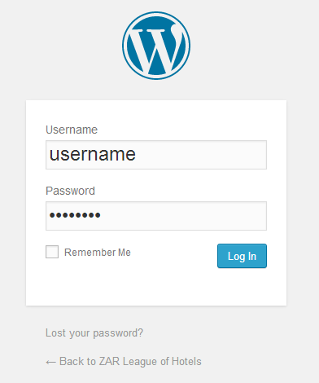

# The Dashboard

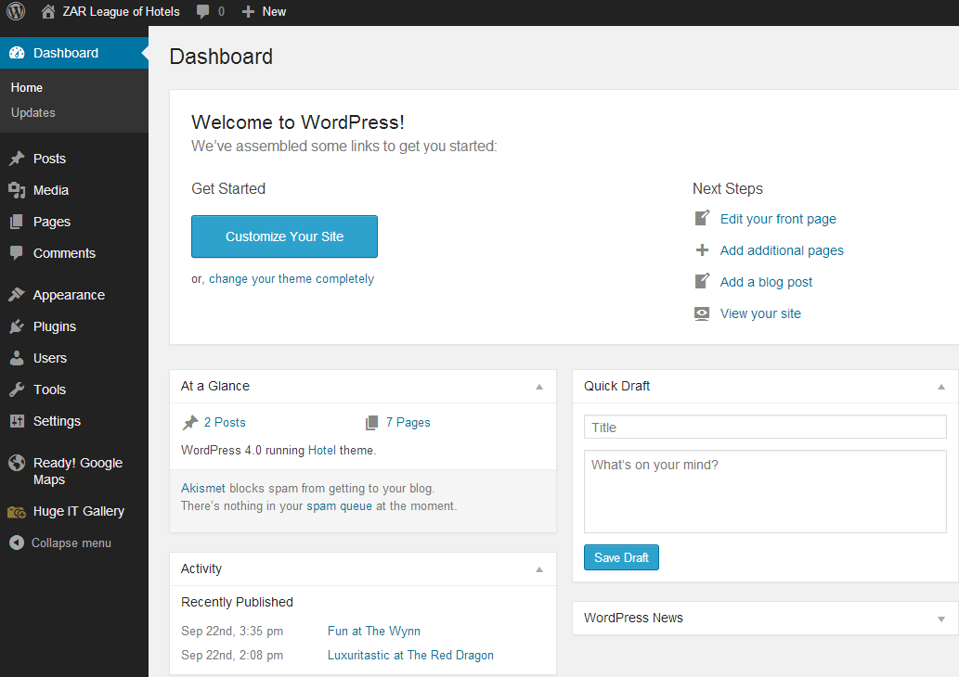

# Dashboard menu options

**Posts**

This is where you can create a new Blog Post. You can also update your Categories and Post Tags.

**Media**

This is where all your uploaded images, documents or files are stored. You can browse through your Media library, as well as edit and update the files.

**Pages**

This is where you create and maintain all your Pages.

**Comments**

You can manage all your Comments within this section, including replying to comments or marking them as spam.

**Appearance**

This menu is where you control how your site looks. You can choose a new Theme, manage your site Widgets or Menus and even edit your site theme files.

**Plugins**

Plugins extend and expand the functionality of WordPress. You can add or delete plugins within here as well as activate or deactivate them.

**Users**

This screen lists all the existing users for your site. Depending on your Role, you can also add new users as well as manage their Roles.

**Tools**

This section gives you access to various convenient tools. You can also import data to your WordPress site or export all your WordPress data to a file.

**Settings**

This is where most of your site is configured. Among other things, it allows you to configure your site name and URL , where your Posts appear, whether people can leave Post Comments or not and numerous other settings. Most times, once your site is setup, there's no need to change any of the settings within this section.

# Permalinks

One of the first settings you’ll want to change on your new WordPress site is the *permalinks*.

Permalinks are the direct, permanent links to any content on your site. It’s what other websites will use to link to your content. By default, WordPress creates permalinks that are less than useful. They have question marks and lots of numbers that are completely meaningless to the average user. They look like this:

*http://www.mysite.com/?p=206*

That garbled mess isn’t helpful to anybody, including search engines. These links obviously work— that number is the ID of the content and they get people where they need to go. But they don’t tell the reader – or search engines – very much, hence they aren’t very useful. A simple improvement is to make your permalinks user friendly. Useful permalinks look like this:

*http://www.mysite.com/title-of-your-post*

That makes your links a lot more useful. It improves the aesthetics, usability and forward compatibility of the links. It’s not only good for humans looking at links, but it can also help your search engine ranking. Having real words in the URL, especially keywords for your content, is a good search engine optimization (SEO) strategy.

These improved, user- and search-engine-friendly permalinks are sometimes called *pretty permalinks*. And it’s easy to use them in WordPress.

# Pages and Posts

## Posts

A WordPress post is what makes up the ‘blog’ aspect of your site. These are generally news or informational updates.

* Usually listed in reverse chronological order—the newest posts show up at the top.
* They can be tagged, categorized and archived.
* Located on the homepage as your primary content, or on a “blog” page.
* Make up your site’s RSS content (the updated information people subscribe to).

For most sites you’ll continually add new posts, creating a dynamic, constantly updating stream of content.

## Pages

A WordPress page is generally reserved for static information, like a product page, an about page or the contact page.

* Not listed by date.
* Usually appear in the site’s menu.
* They cannot be tagged, categorized or archived by date.
* Not included in your site’s RSS feed.

## Child Pages

Unlike posts, which are listed by date and can be tagged and categorized, pages are added to your site’s menu and can be organized by hierarchy.

You can create top-level “parent” pages that are visible in the menu and lower level ‘child’ pages that only appear in the menu when you mouse over the parent page.

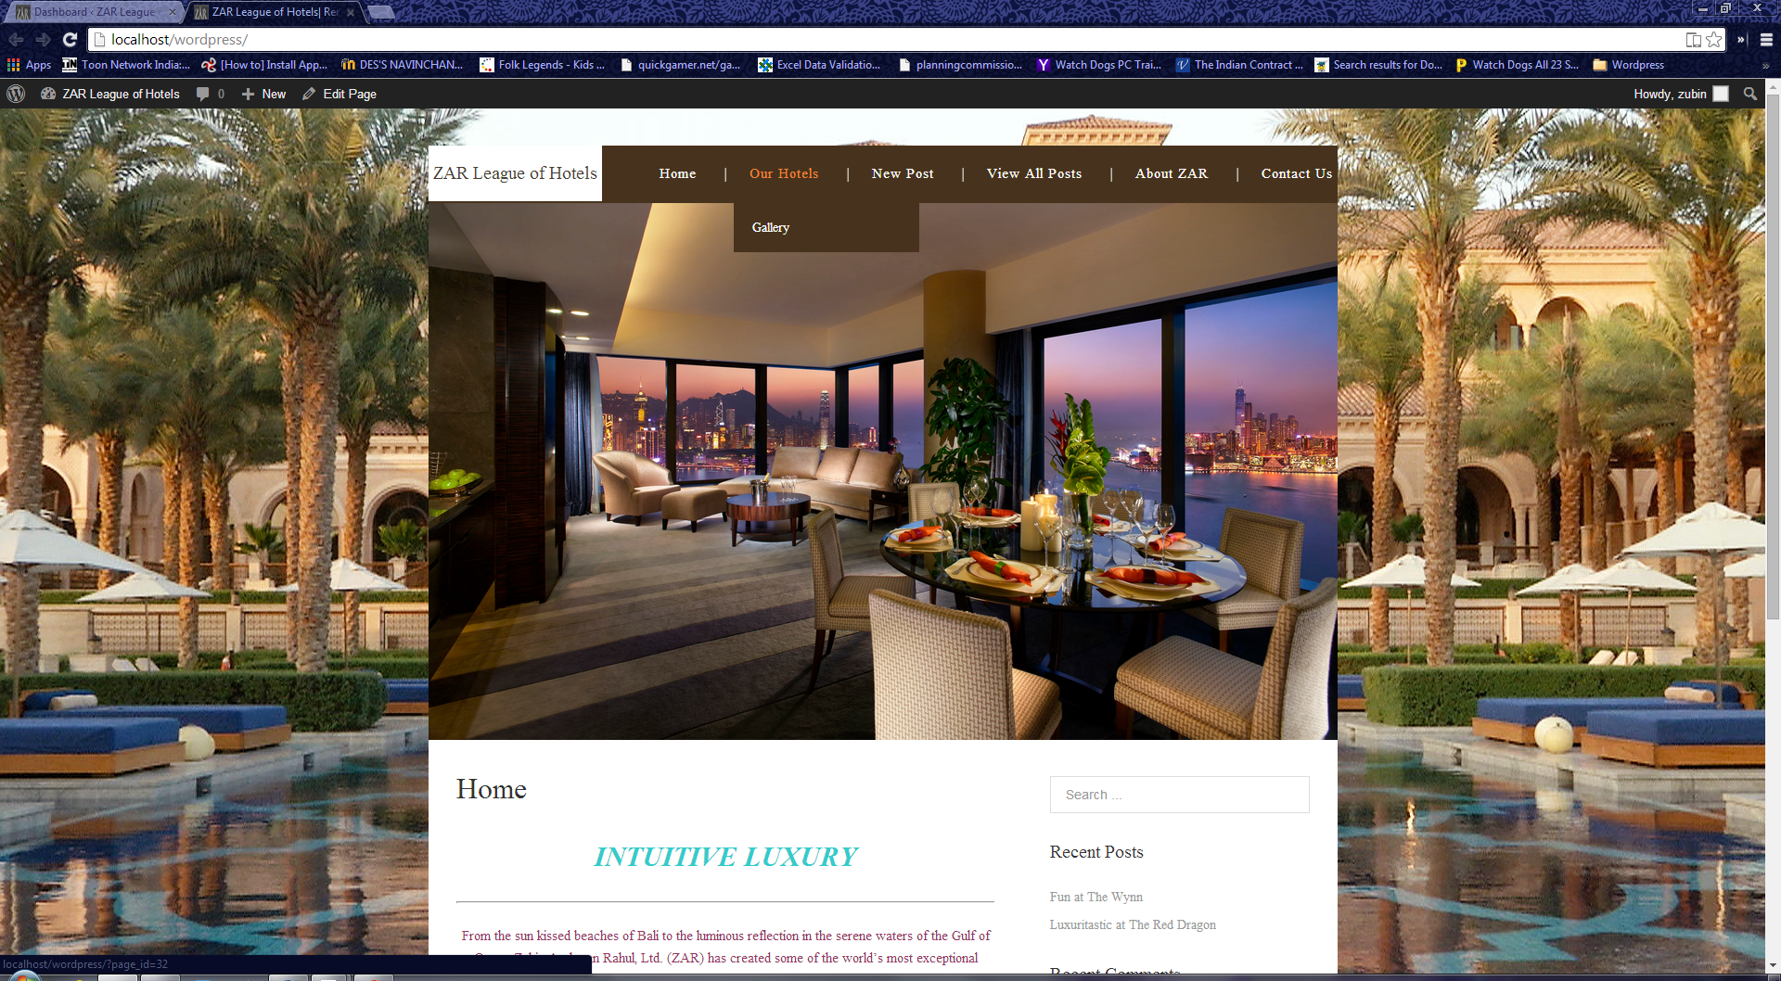

*Example of a child page*

# Appearance

The various Appearance menus allow you to change how your site looks and behaves. If your site has been setup for you by a third party then it’s more than likely that you won’t need to change any of the settings in here.

Depending on the theme that your site is running, you may find that you don’t have all the menu options listed here, or you may have a couple of different ones.

The reason for this is that a couple of the options under the *Appearance* section are theme based.

For example, the default *Twenty Fourteen* theme allows you to customize options for how your theme displays.

Not all themes will have these option pages, or if they do, they may be under another menu entirely.

There are hundreds of places where themes can be downloaded for free and/or for a small fee. One of the best places to start looking for themes is in the official *WordPress Themes Directory*.

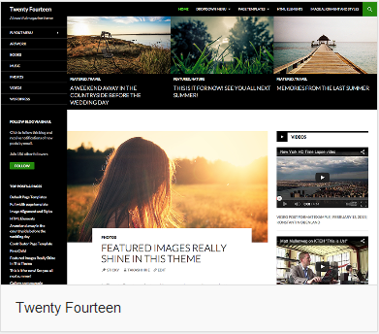

*The twenty fourteen theme*

# Widgets

Widgets are independent sections of content that can be placed into any widgetized area provided by your theme. Although these widgetized areas are commonly called ‘Sidebars’ and are quite often located in the left or right hand column, they can be also located anywhere within your site and are entirely dependent on the current theme as to their location. Lots of themes use these widgetized sidebars in the footer area.

There are numerous widgets available by default which allow you to add extra content to your site, such as Recent Comments, Categories or Custom Menus, just to name a few. New Widgets can also be installed via plugins and again, depending what the plugin is used for the extra functionality it brings to your site will vary.

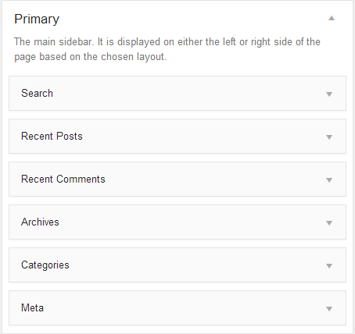

*Primary widgets in every theme*

# Plugins

## What Is a Plugin?

WordPress Plugins are pieces of software that extend the core capabilities of WordPress. They let you do more.

Since WordPress is open source software, these are all third party tools that add-on to what WordPress can do. They’re easy to download and install. Some are premium (there is a fee to purchase them) and others are free.

You may want to read the “Getting Started with Plugins” e-book available from PluginBuddy.com. This 21-page (free) guide gives you the best practices you should be using when working with plugins.

Plugins can do things like improve your search engine optimization (All-in-One SEO Pack), is play related posts in your sidebar (Yet another Related Posts Plugin), do complete backups of your WordPress site (Backup Buddy) or create stunning web forms quickly and easily (Gravity Forms). You can add just about any functionality to WordPress with plugins.

The WordPress Plugin Directory is a repository of free plugins that have been (somewhat) vetted. There are currently more than 18,000 plugins in the WordPress directory, so there’s a lot to choose from.

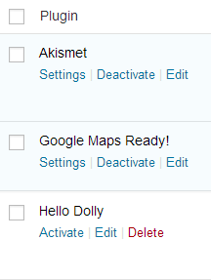

# Comparing WordPress, Joomla and Drupal

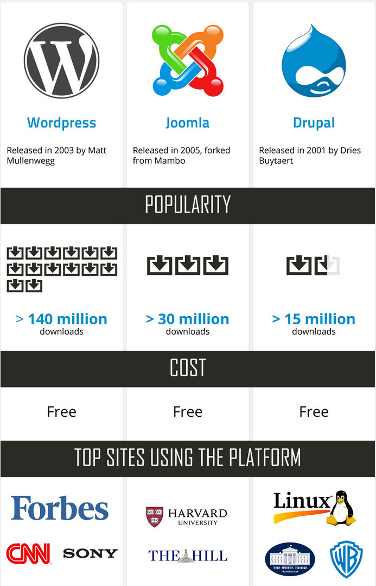



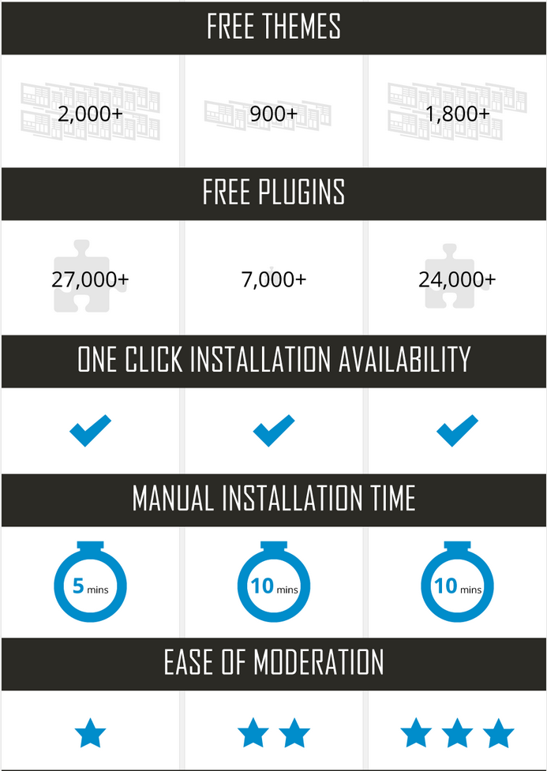



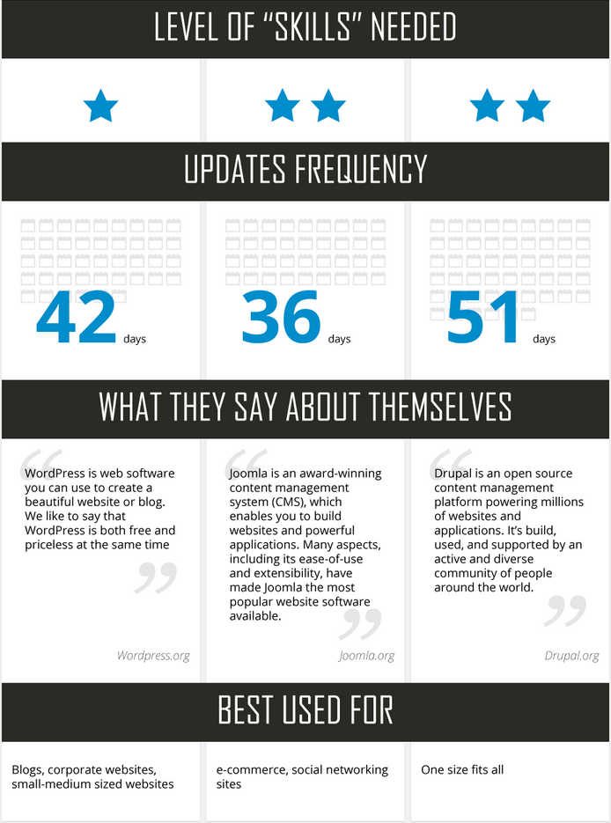

# Case Study – Hotel Management

## Pages

The following pages have been included in our site:

*(In order of menu)*

* Home
* Our Hotels
  + Gallery
* New Post
* View All Posts
* About ZAR
* Contact Us

Apart from using the default WordPress facility of providing posts, we have implemented a third – party plugin (discussed later) for providing us and users with the service of managing posts and an interesting way of creating new posts, details of which will be provided later in the documentation.

## Theme

The following theme has been used in our site:

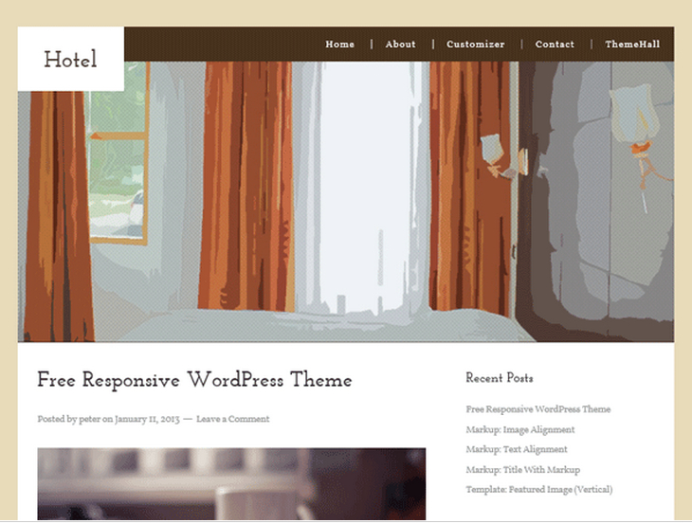

*Hotel by themehall.com – A child theme of Omega*

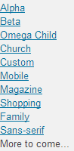

*More themes of Omega*

## Plugins

The following plugins have been used is our site:

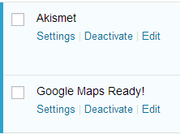 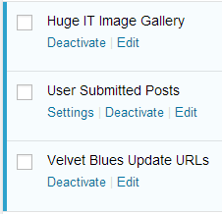

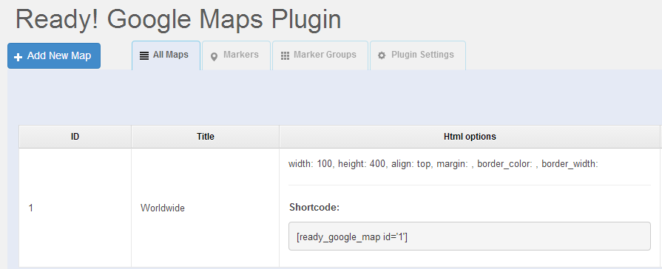

*Ready! Google Maps Plugin*

## Screens

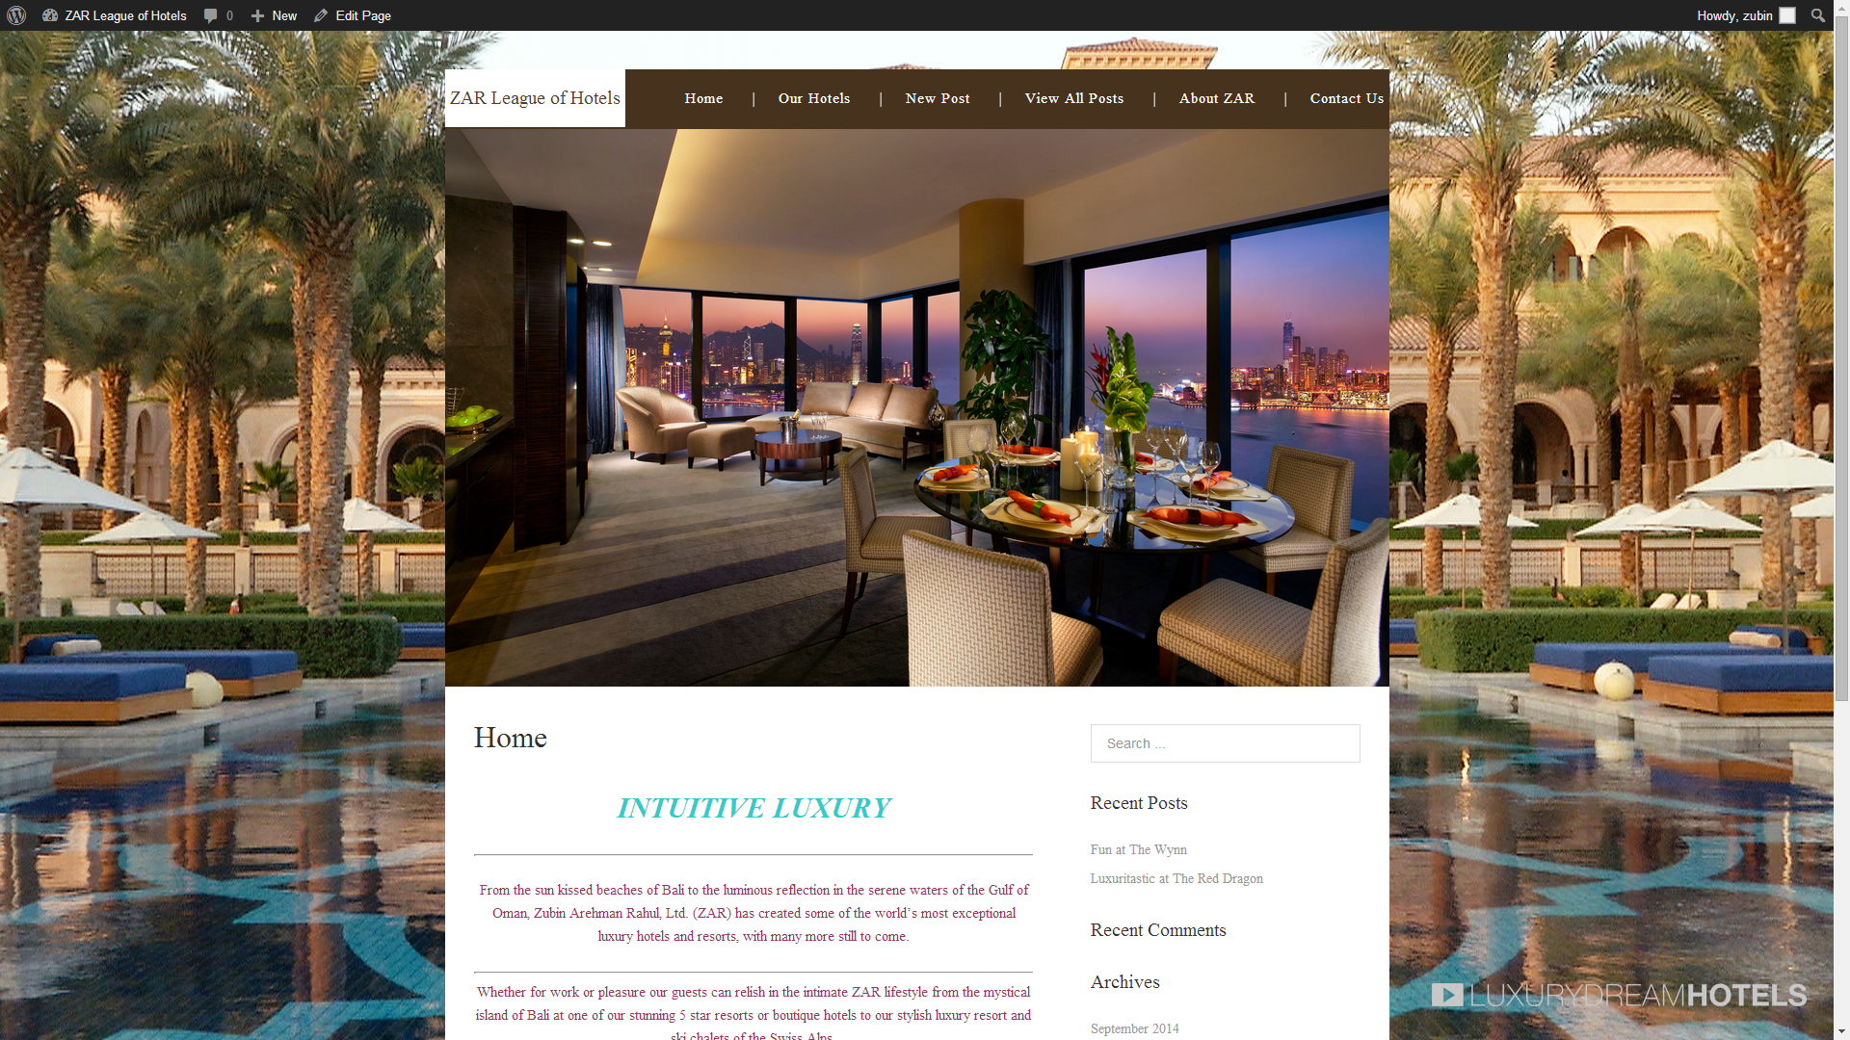

*The Home Page*

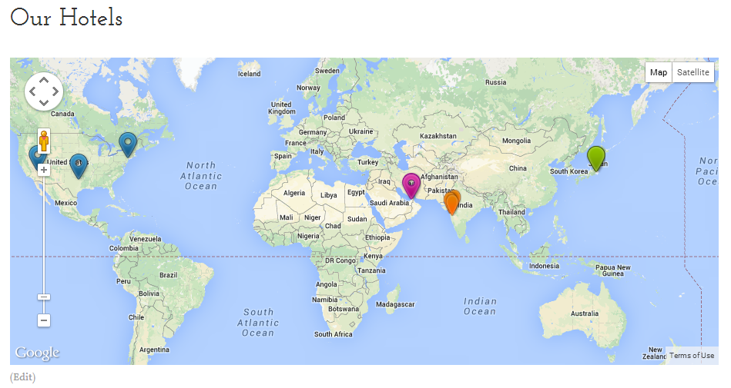

*Our Hotels with Google Maps Ready! Plugin*

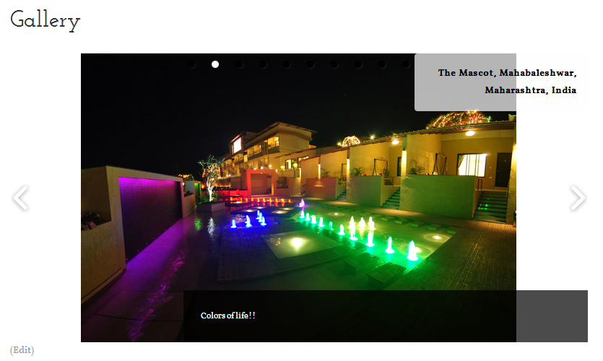

*Image Slider with Huge IT Gallery Plugin*

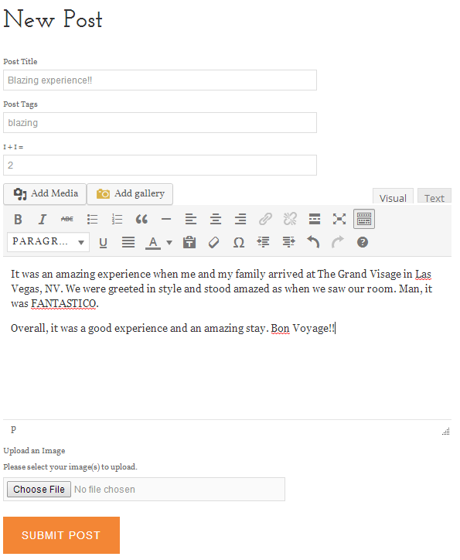

*Writing a new post*

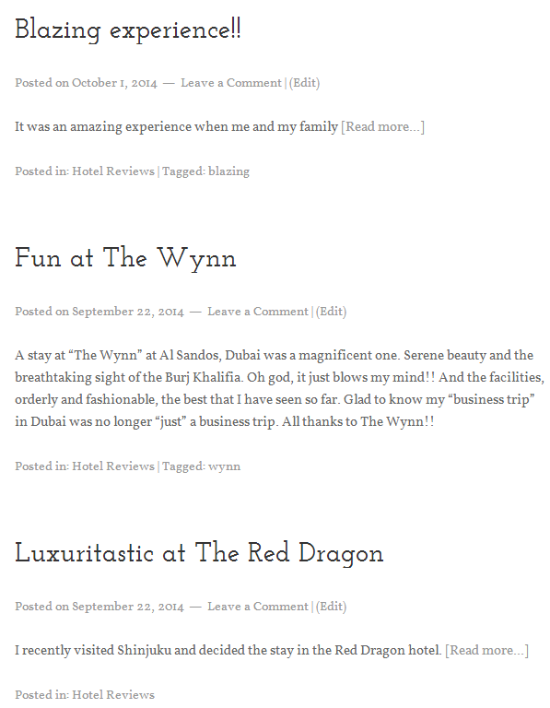

*View all posts*

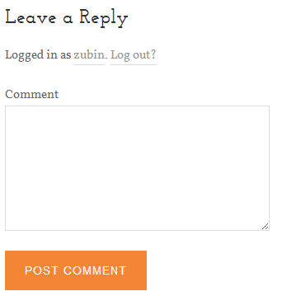

*Comments*

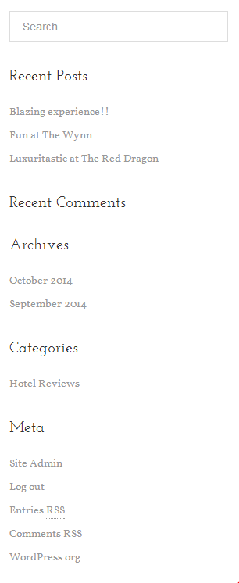

*Primary widgets*

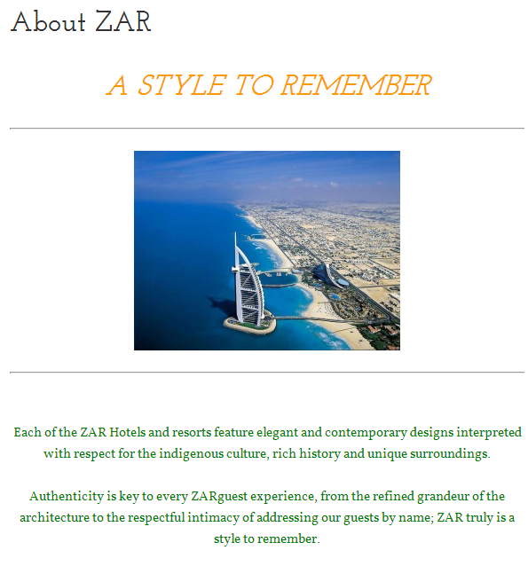

*About Us*

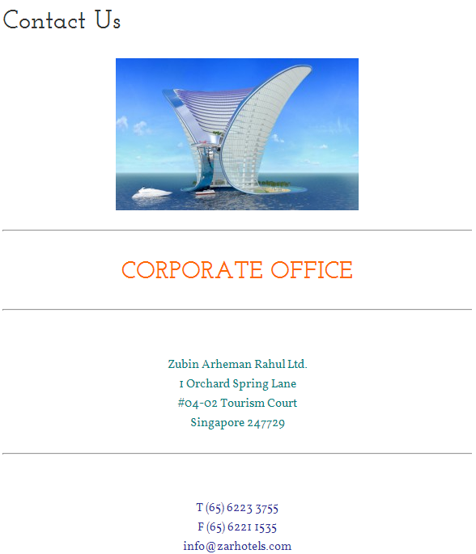

*Contact Us*

# References and Bibliography

*https://www.wordpress.com/*

*https://www.wordpress.org/*

*en.wikipedia.org/wiki/WordPress*

*en.blog.wordpress.com*

*http://www.theme.wordpress.com/*

*http://www.siteground.com/tutorials/wordpress/*

*http://www.wptiger.com/*

*https://www.yoast.com/wordpress/*